**Aim:**

To design and Implement Mini-project on Machine learning / Blockchain topics

**PawFund - Decentralized Rescue System (DRS)**

**Theory**

Animal rescue and adoption processes across the world face serious issues such as lack of transparency, fragmented systems, and misuse of donor funds. Many rescue centers and shelters work independently without a unified platform, making it difficult to track animals, manage resources, or build trust with donors and adopters. Inconsistent record-keeping and the absence of a verifiable system often discourage public participation and lead to inefficiencies in helping animals in need.



PawFund – Decentralized Rescue System (DRS) addresses these challenges by providing a blockchain-based platform that ensures transparent, secure, and verifiable rescue operations. Using smart contracts, all activities like animal registration, adoptions, and donations are immutably recorded on the blockchain, making them easily traceable and tamper-proof. PawFund connects shelters, volunteers, adopters, and donors in a decentralized network, removing the need for centralized authorities while ensuring fair and automated transactions.



By leveraging blockchain technology, PawFund empowers the animal welfare community with tools for trustless collaboration, verifiable fund distribution, and global accessibility. The platform also introduces incentive mechanisms to encourage active participation from volunteers and donors, creating a self-sustaining ecosystem for animal rescue.

**Tech Stack**

**Frontend:**

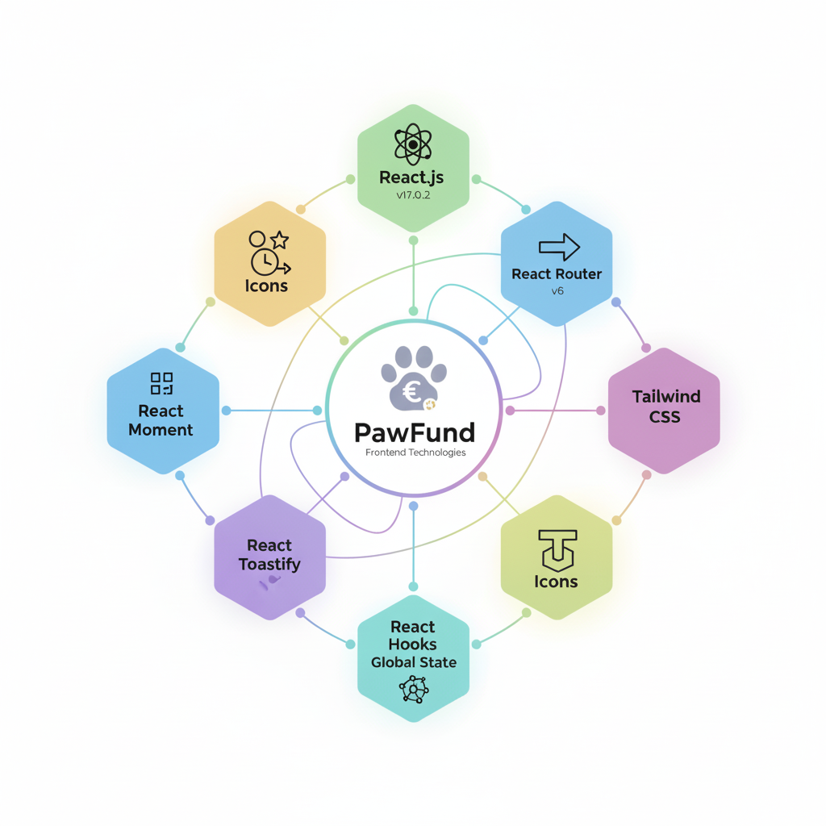

**Blockchain & Web3:**

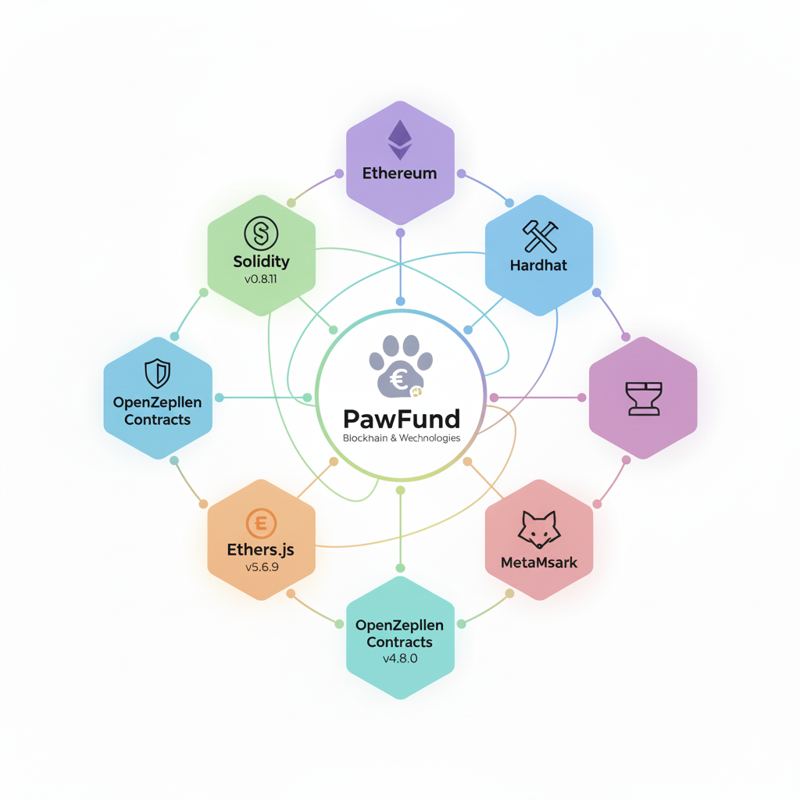

**Steps performed**

The implementation of the PawFund Decentralized Animal Rescue System involves several steps to ensure secure donation, rescue, and adoption management using blockchain technology.

Here’s the core algorithm followed:

1. **User Authentication**

* Connect user's digital wallet (MetaMask / Google) to the platform.
* Authenticate user through wallet signature verification.

1. **Pet Listing**

* Admin/shelter registers a new pet.
* Pet details (name, breed, age, health info) are entered.
* A smart contract function addPet() is called to store the pet on blockchain.

1. **Rescue Request**

* Any user can create a rescue request by submitting rescue details.
* Rescue request is stored on blockchain via createRescueRequest().

1. **Donation Process**

* Donors select a rescue case to fund.
* Donation amount is entered, and the smart contract donateToRescue() is invoked.
* Transaction details are recorded immutably.

1. **Verification and Updates**

* Admin verifies rescue status or adoption post-processing.
* Records are updated via blockchain transaction calls.

**Code-** Solidity Code File (Blockchain):

//SPDX-License-Identifier: MIT pragma solidity ^0.8.7;

contract Genesis { address public owner;

uint public projectTax; uint public projectCount; uint public balance; statsStruct public stats; projectStruct[] projects;

mapping(address => projectStruct[]) projectsOf; mapping(uint => backerStruct[]) backersOf; mapping(uint => bool) public projectExist;

enum statusEnum { OPEN, APPROVED, REVERTED, DELETED, PAIDOUT

}

struct statsStruct { uint totalProjects; uint totalBacking; uint totalDonations;

}

struct backerStruct { address owner; uint contribution; uint timestamp; bool refunded;

}

struct projectStruct { uint id;

address owner; string title; string description; string imageURL;

uint cost; uint raised; uint timestamp; uint expiresAt; uint backers;

statusEnum status;

}

modifier ownerOnly(){

require(msg.sender == owner, "Owner reserved only");

_;

}

event Action ( uint256 id,

string actionType, address indexed executor, uint256 timestamp

);

constructor(uint _projectTax) { owner = msg.sender; projectTax = _projectTax;

}

function createProject( string memory title,

string memory description, string memory imageURL, uint cost,

uint expiresAt

) public returns (bool) { require(bytes(title).length > 0, "Title cannot be

empty");

require(bytes(description).length > 0, "Description cannot be empty");

require(bytes(imageURL).length > 0, "ImageURL cannot be empty");

require(cost > 0 ether, "Cost cannot be zero");

projectStruct memory project; project.id = projectCount; project.owner = msg.sender; project.title = title; project.description = description;

project.imageURL = imageURL; project.cost = cost; project.timestamp = block.timestamp; project.expiresAt = expiresAt;

projects.push(project); projectExist[projectCount] = true; projectsOf[msg.sender].push(project); stats.totalProjects += 1;

emit Action (

projectCount++, "PROJECT CREATED",

msg.sender, block.timestamp

);

return true;

}

function updateProject( uint id,

string memory title, string memory description, string memory imageURL, uint expiresAt

) public returns (bool) {

require(msg.sender == projects[id].owner, "Unauthorized Entity");

require(bytes(title).length > 0, "Title cannot be empty");

require(bytes(description).length > 0, "Description cannot be empty");

require(bytes(imageURL).length > 0, "ImageURL cannot be empty");

projects[id].title = title; projects[id].description = description; projects[id].imageURL = imageURL; projects[id].expiresAt = expiresAt;

emit Action (

id,

"PROJECT UPDATED",

msg.sender, block.timestamp

);

return true;

}

function deleteProject(uint id) public returns (bool) { require(projects[id].status == statusEnum.OPEN,

"Project no longer opened");

require(msg.sender == projects[id].owner, "Unauthorized Entity");

projects[id].status = statusEnum.DELETED; performRefund(id);

emit Action (

id,

"PROJECT DELETED",

msg.sender, block.timestamp

);

return true;

}

function performRefund(uint id) internal {

for(uint i = 0; i < backersOf[id].length; i++) { address _owner = backersOf[id][i].owner;

uint _contribution = backersOf[id][i].contribution;

backersOf[id][i].refunded = true; backersOf[id][i].timestamp = block.timestamp; payTo(_owner, _contribution);

stats.totalBacking -= 1; stats.totalDonations -= _contribution;

}

}

function backProject(uint id) public payable returns (bool)

{

require(msg.value > 0 ether, "Ether must be greater

than zero");

require(projectExist[id], "Project not found"); require(projects[id].status == statusEnum.OPEN,

"Project no longer opened");

stats.totalBacking += 1; stats.totalDonations += msg.value; projects[id].raised += msg.value; projects[id].backers += 1;

backersOf[id].push( backerStruct(

msg.sender, msg.value, block.timestamp, false

)

);

emit Action (

id,

"PROJECT BACKED",

msg.sender, block.timestamp

);

if(projects[id].raised >= projects[id].cost) { projects[id].status = statusEnum.APPROVED; balance += projects[id].raised; performPayout(id);

return true;

}

if(block.timestamp >= projects[id].expiresAt) { projects[id].status = statusEnum.REVERTED; performRefund(id);

return true;

}

return true;

}

function performPayout(uint id) internal { uint raised = projects[id].raised;

uint tax = (raised * projectTax) / 100; projects[id].status = statusEnum.PAIDOUT; payTo(projects[id].owner, (raised - tax));

payTo(owner, tax);

balance -= projects[id].raised; emit Action (

id,

"PROJECT PAID OUT",

msg.sender, block.timestamp

);

}

function requestRefund(uint id) public returns (bool) { require(

projects[id].status != statusEnum.REVERTED || projects[id].status != statusEnum.DELETED, "Project not marked as revert or delete"

);

projects[id].status = statusEnum.REVERTED; performRefund(id);

return true;

}

function payOutProject(uint id) public returns (bool) { require(projects[id].status == statusEnum.APPROVED,

"Project not APPROVED"); require(

msg.sender == projects[id].owner || msg.sender == owner,

"Unauthorized Entity"

);

performPayout(id); return true;

}

function changeTax(uint _taxPct) public ownerOnly { projectTax = _taxPct;

}

function getProject(uint id) public view returns (projectStruct memory) {

require(projectExist[id], "Project not found");

return projects[id];

}

function getProjects() public view returns (projectStruct[] memory) {

return projects;

}

function getBackers(uint id) public view returns (backerStruct[] memory) {

return backersOf[id];

}

function payTo(address to, uint256 amount) internal {

(bool success, ) = payable(to).call{value: amount}(""); require(success);

}

}

**Output screenshots**

**Welcome Page:**

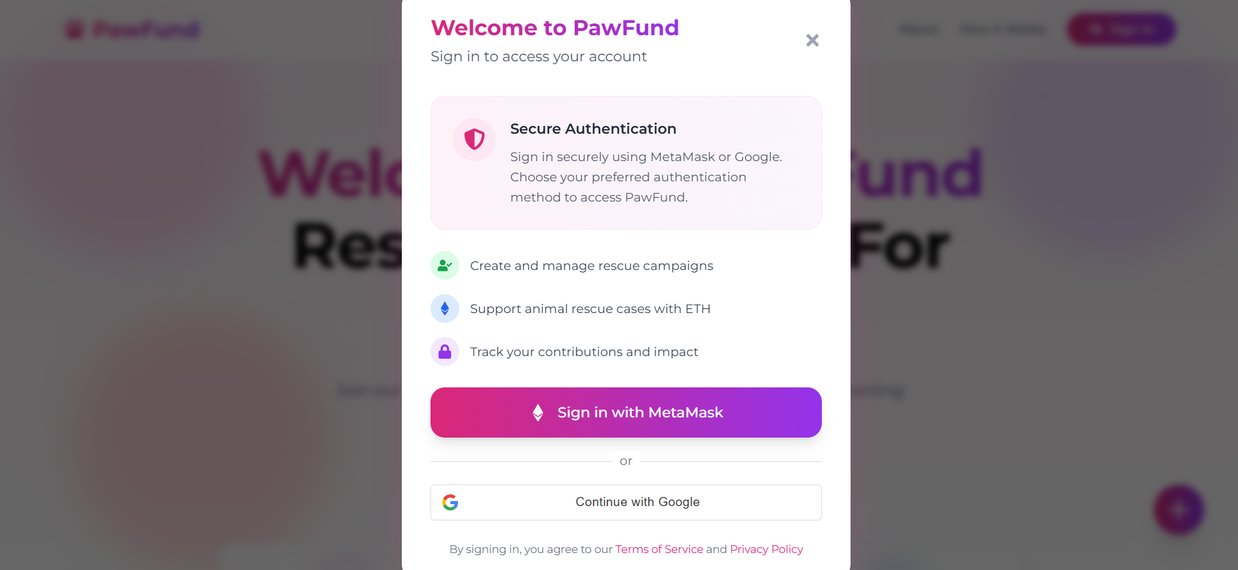

**Homepage:**

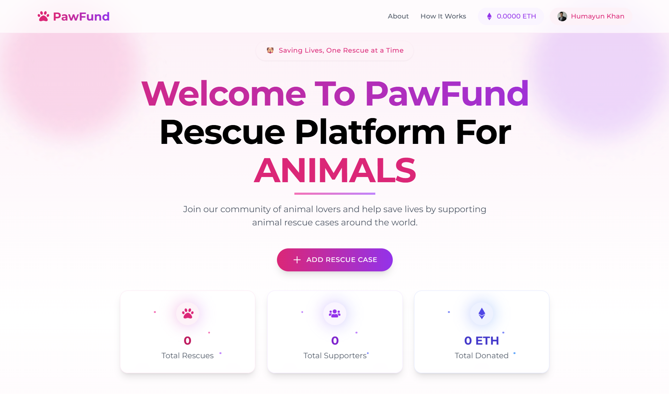

**Rescue cases dashboard:**

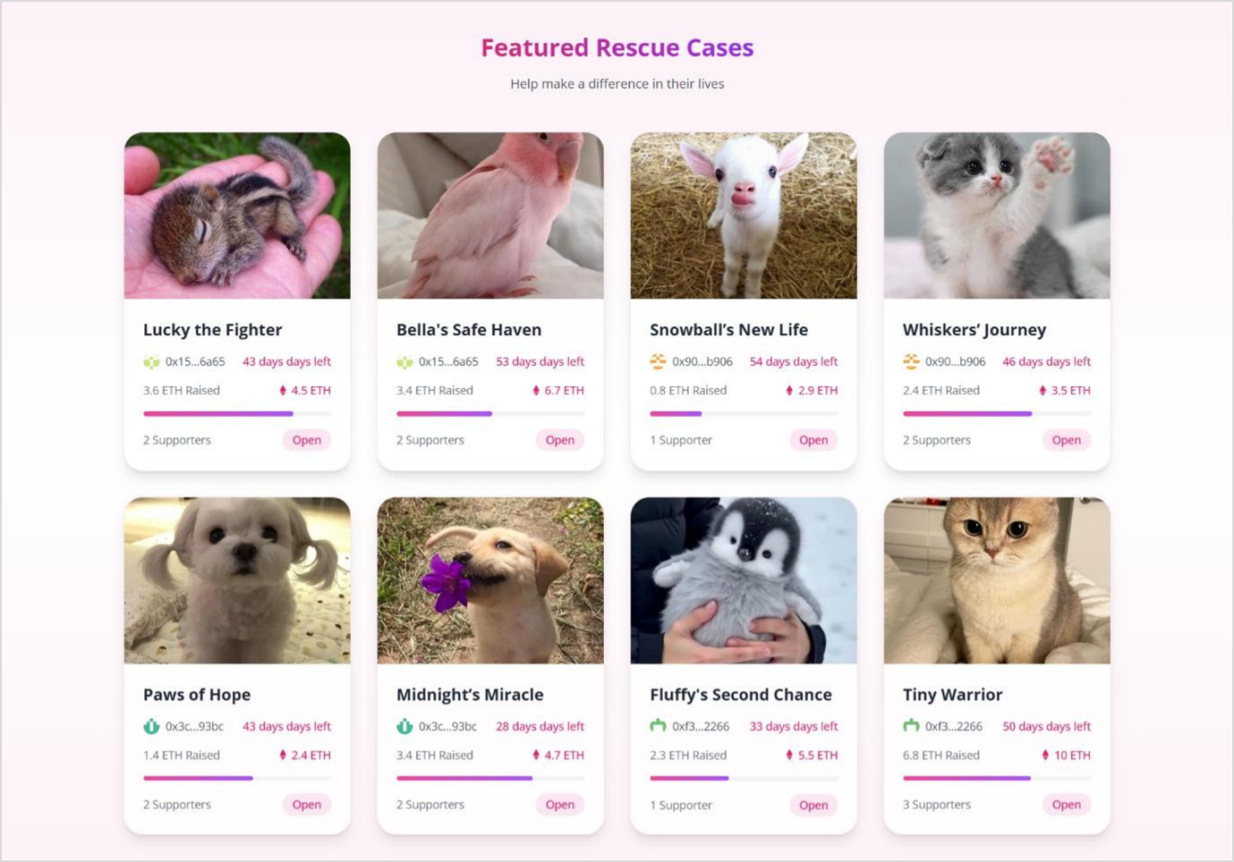

**Create rescue case:**

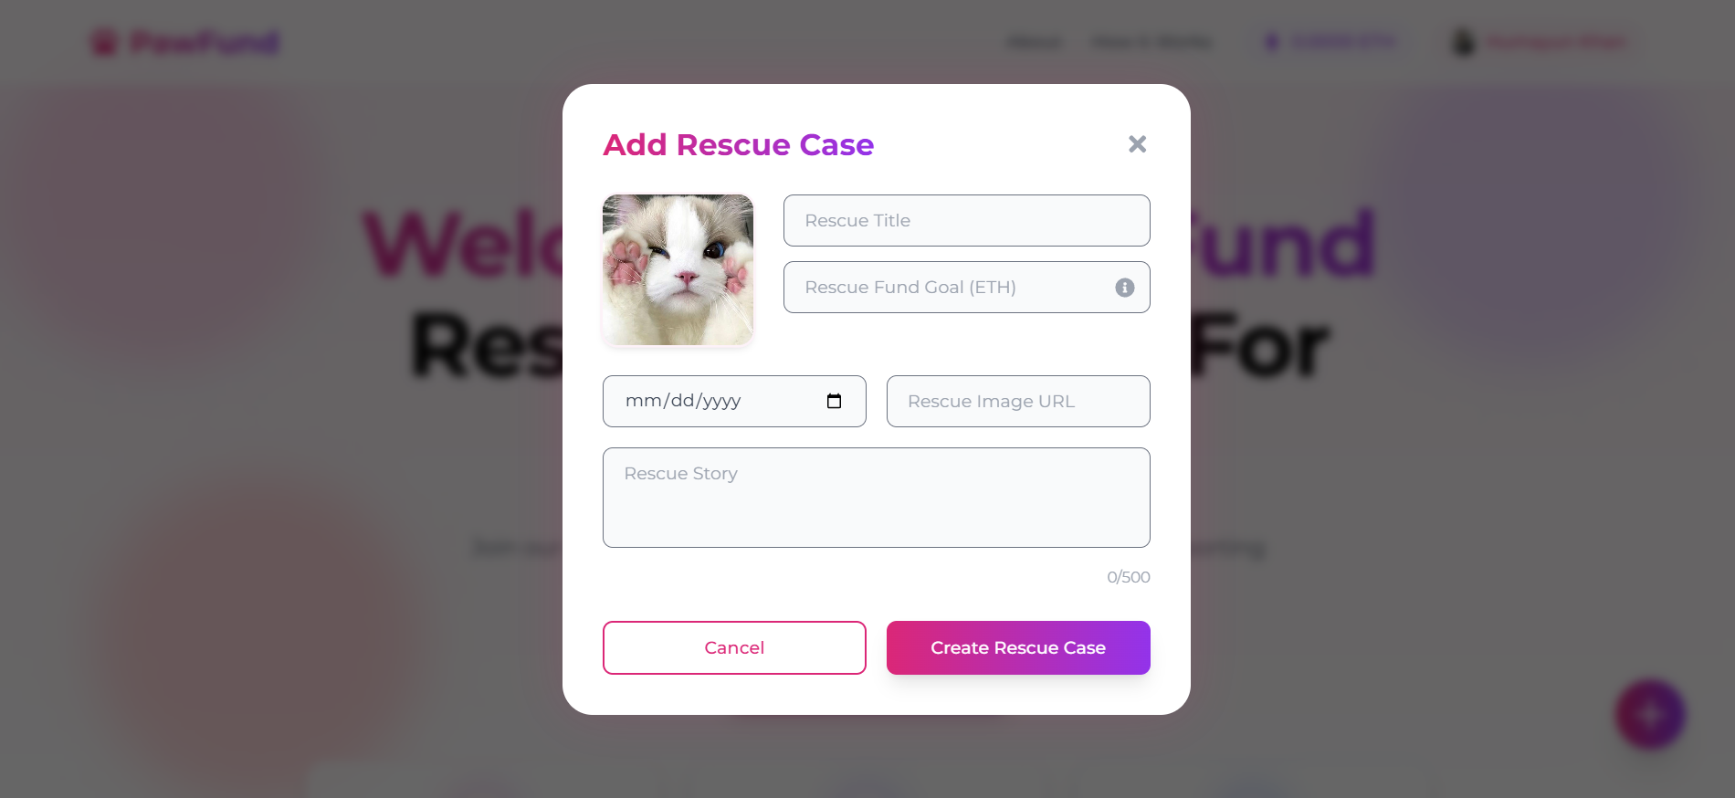

**About us:**

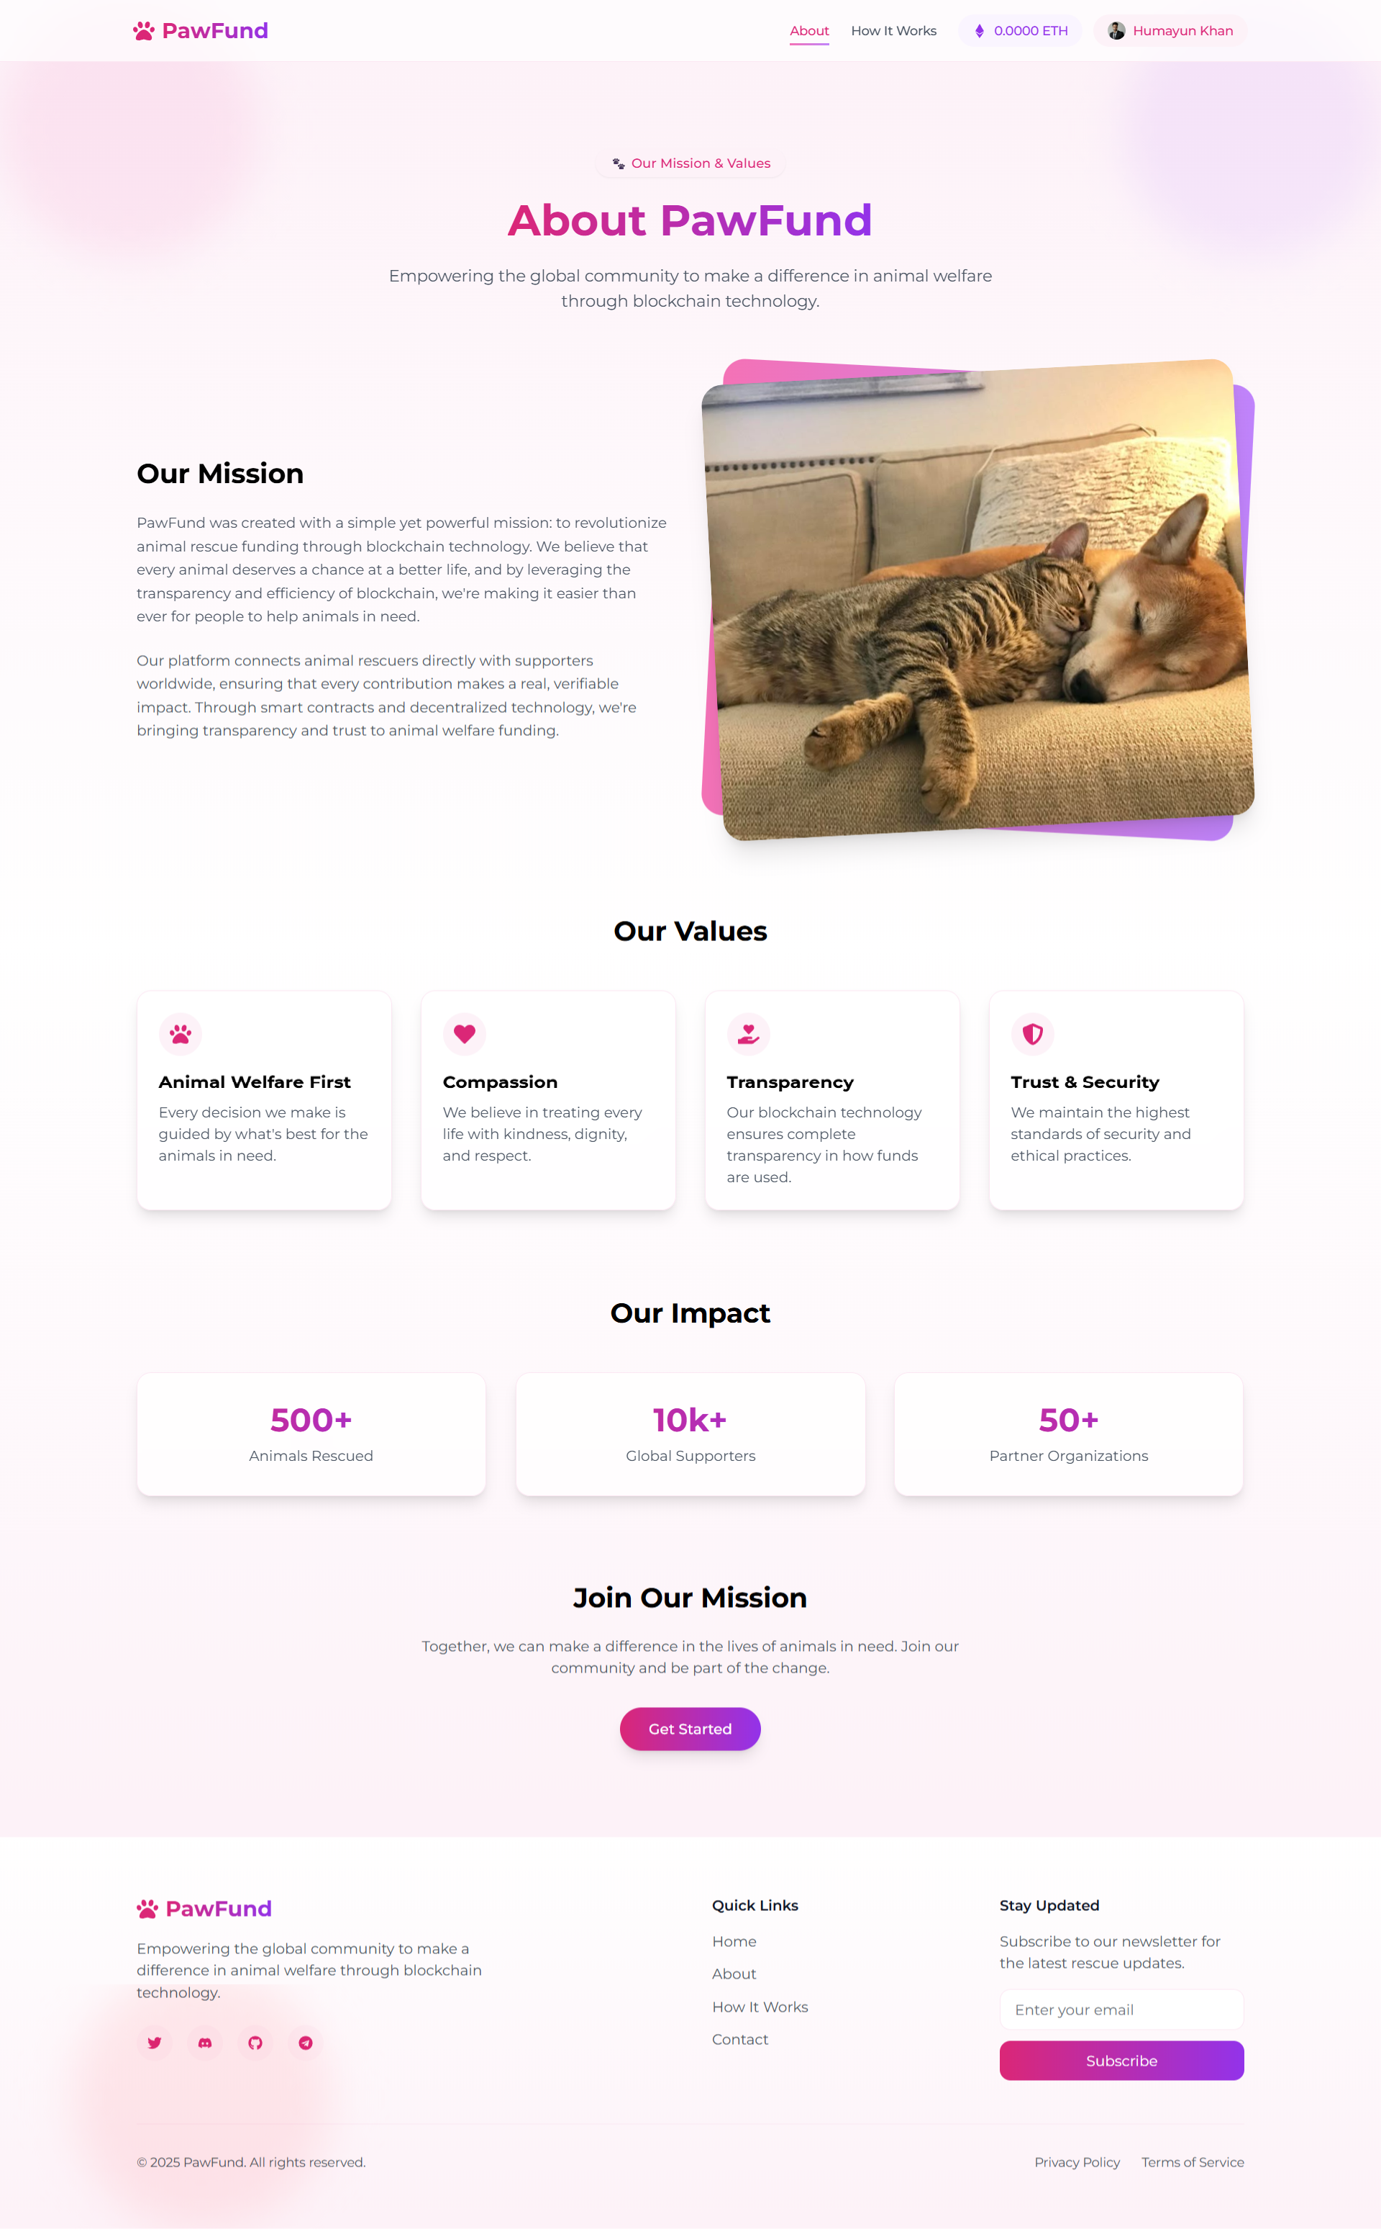

**How it works:**

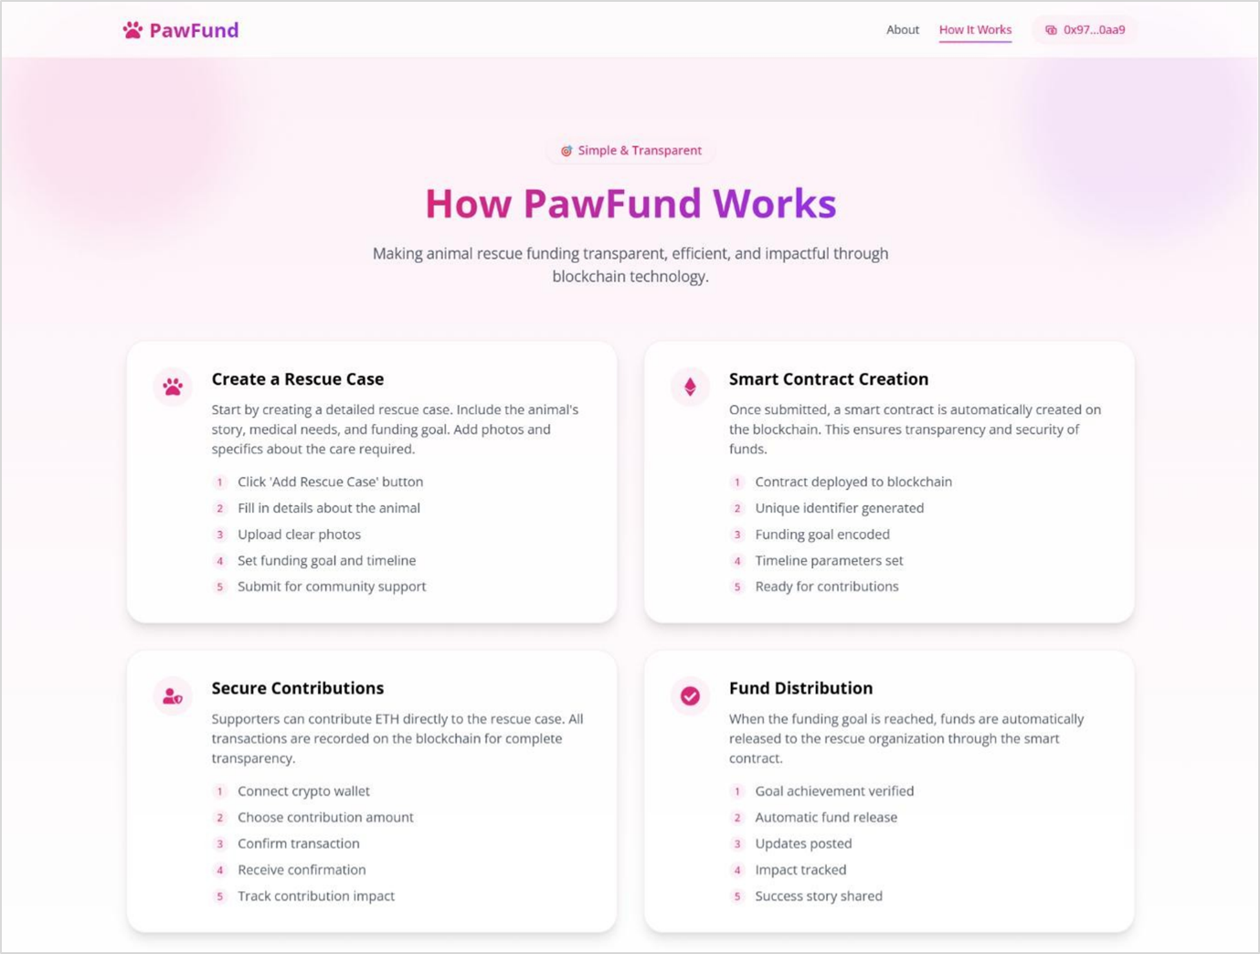

**Featured cases:**

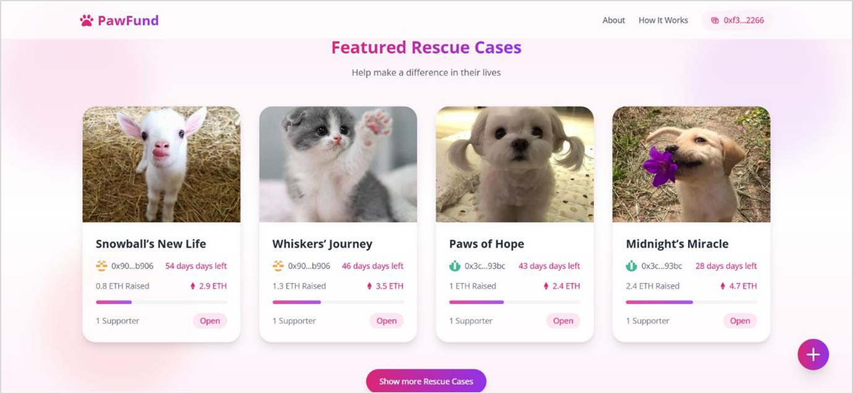

**Create new case campaign:**



**Edit Mission:**

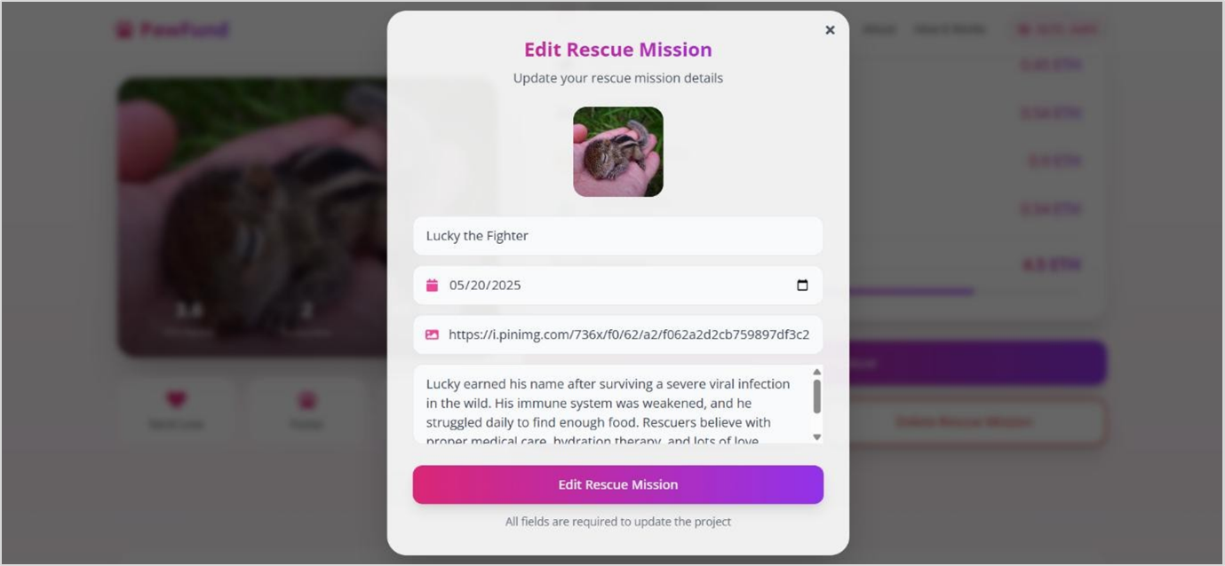

**Delete Mission:**

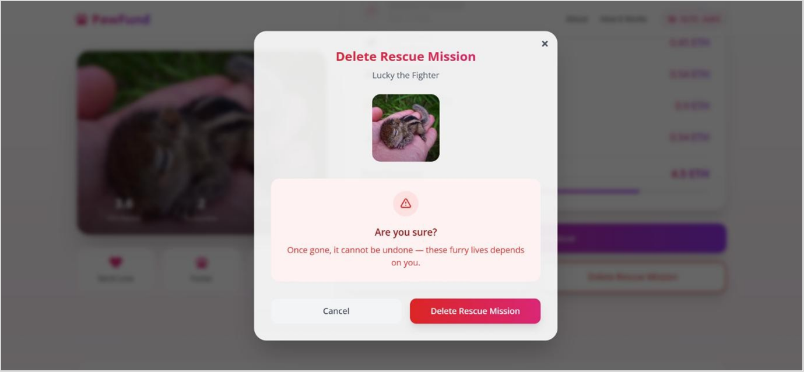

**Support & Donation page:**

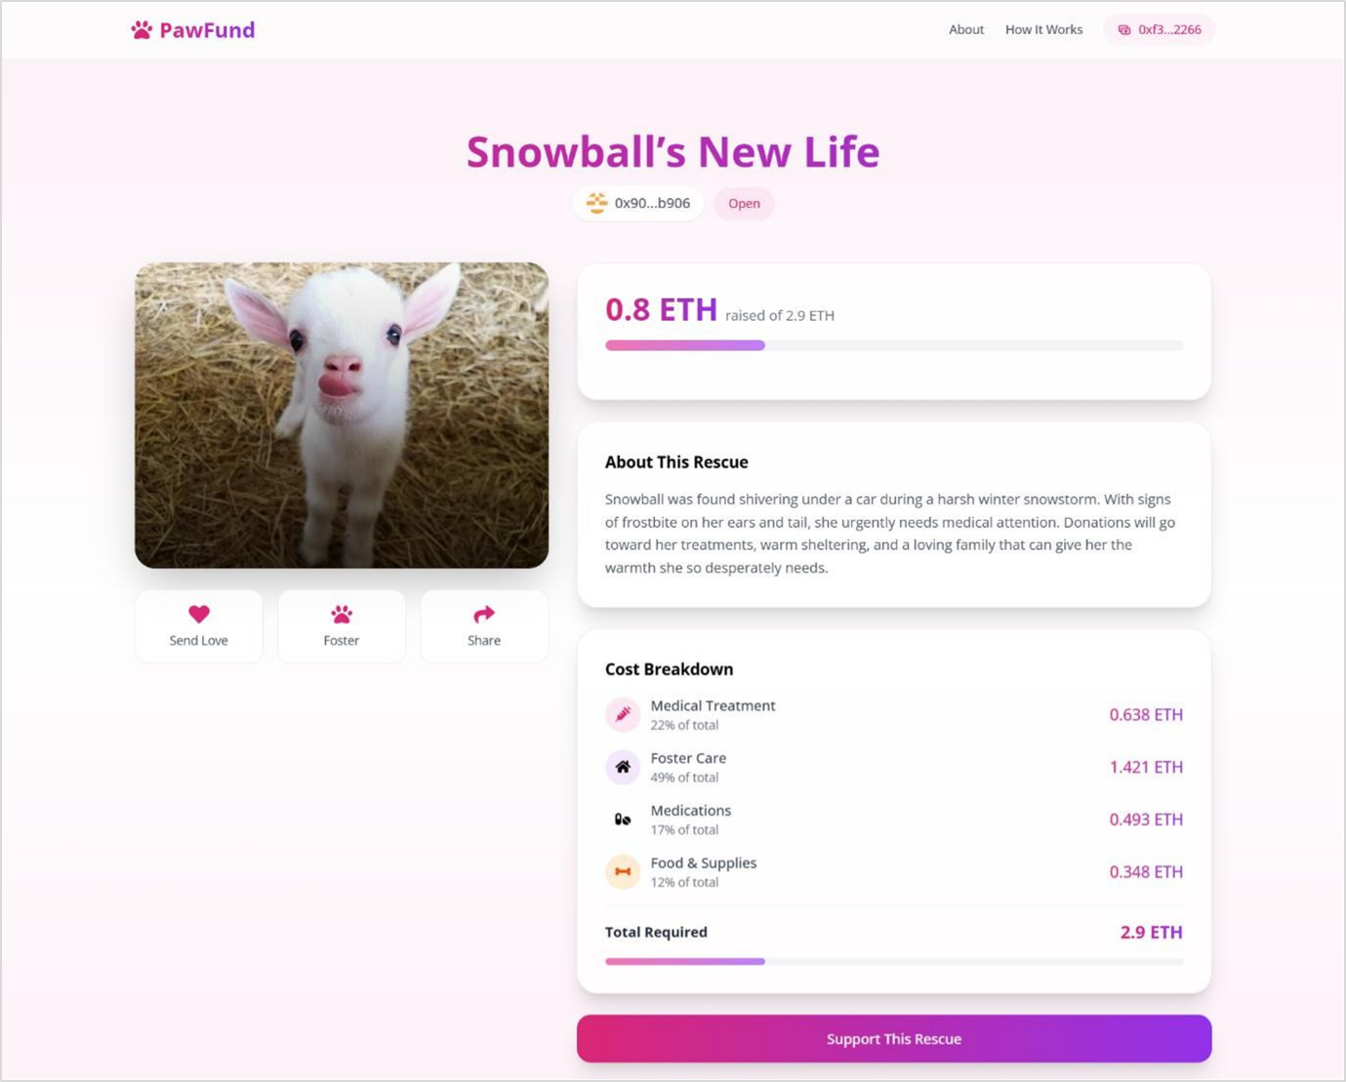

**Supporters List:**

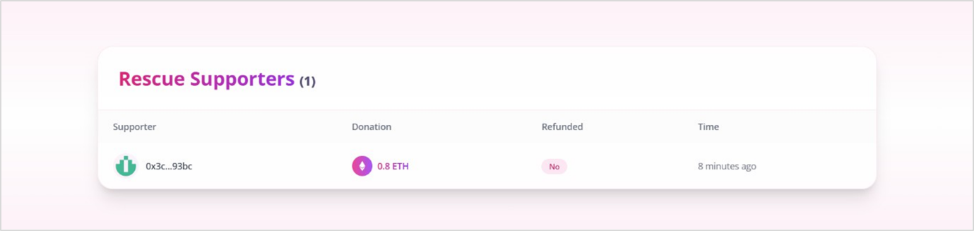

**User testimonials:**

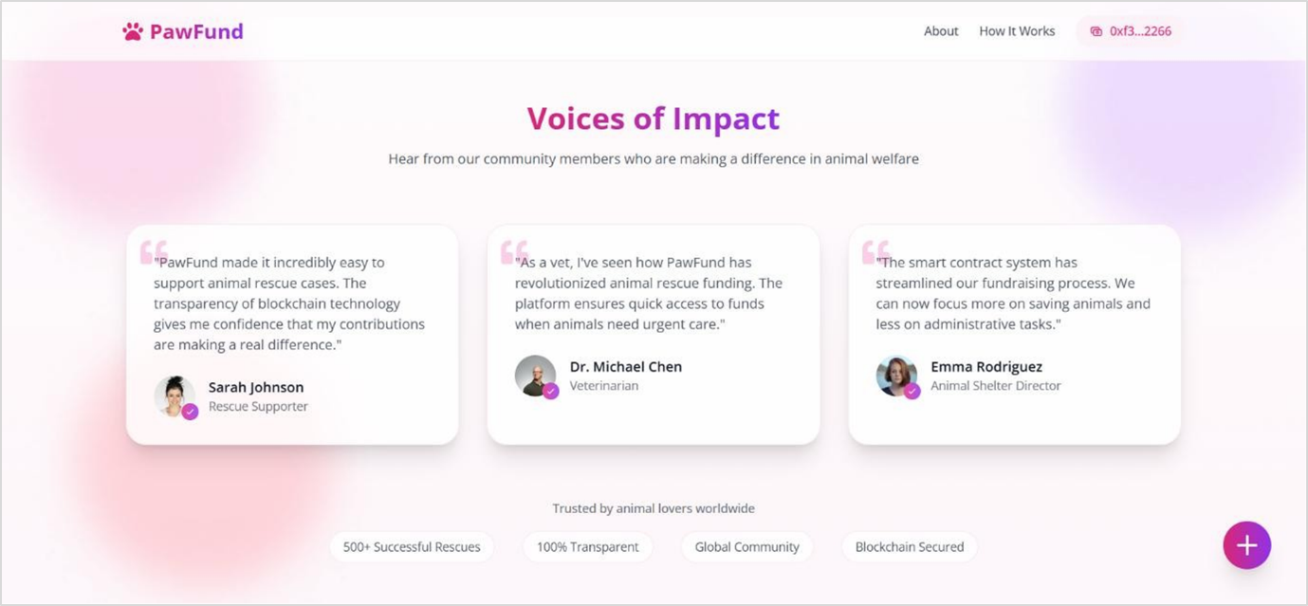

**FAQ Section:**

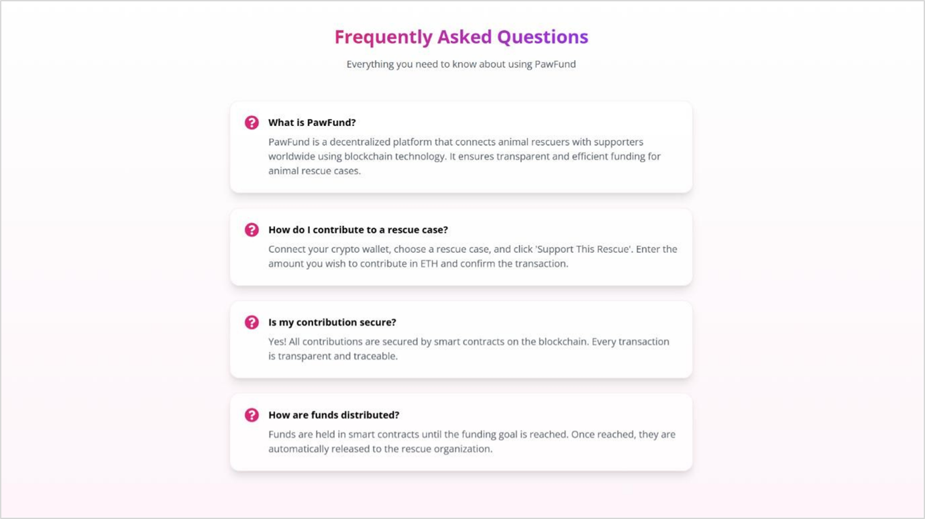

**Profile Page:**

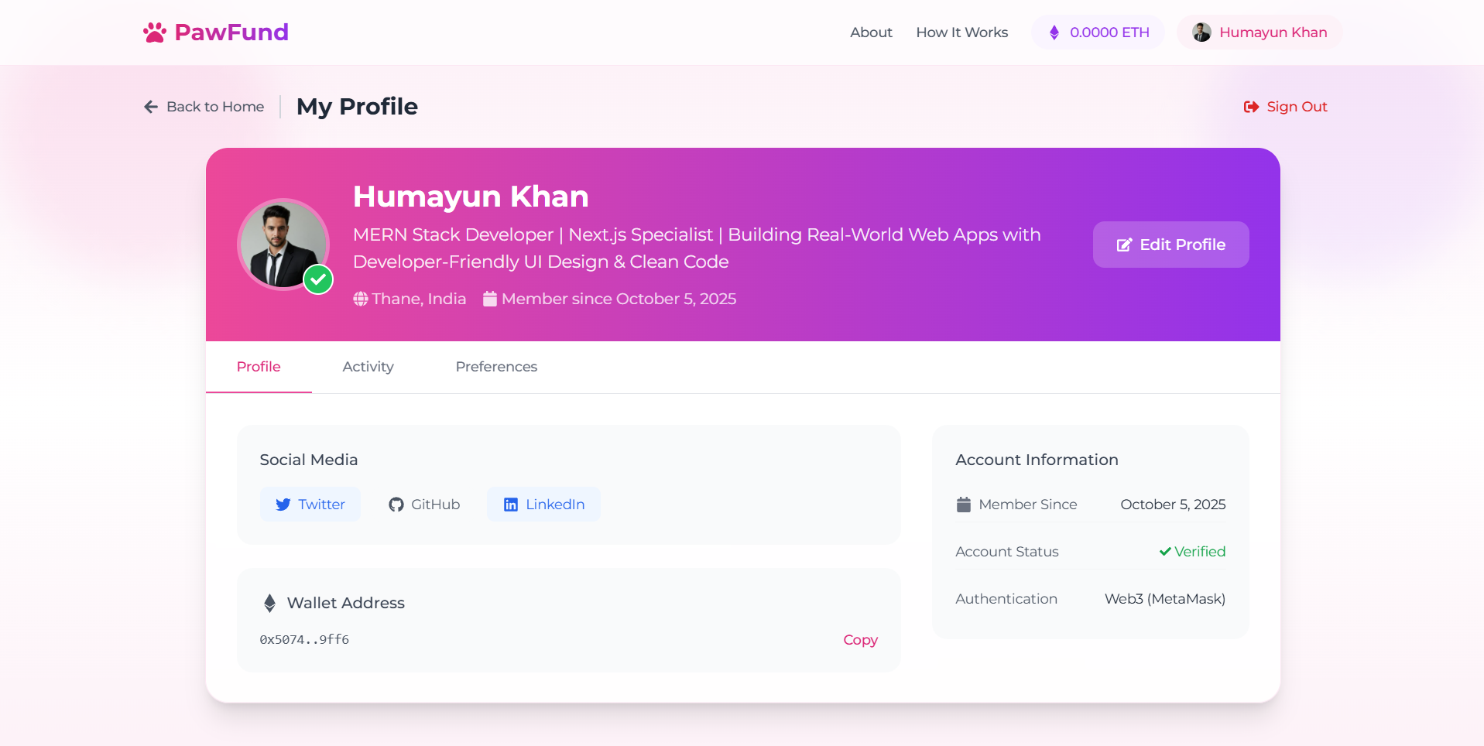

**Conclusion**

**PawFund** is a decentralized blockchain-based platform designed to transform global pet fundraising. By removing intermediaries, it ensures donations are transparent, secure, and directly reach animal shelters and rescue organizations. With blockchain’s immutability and real-time tracking, donors gain unmatched trust and visibility, while decentralized storage (e.g., IPFS) safeguards sensitive campaign data. Despite its promise, challenges like regulatory compliance, user adoption, blockchain complexity, and scalability remain. Addressing these with user-friendly interfaces, multilingual support, smart contract enhancements, and integration with traditional banking can boost accessibility and impact.